FLATBREAD PIZZA

- Preheat oven to 375 degrees.

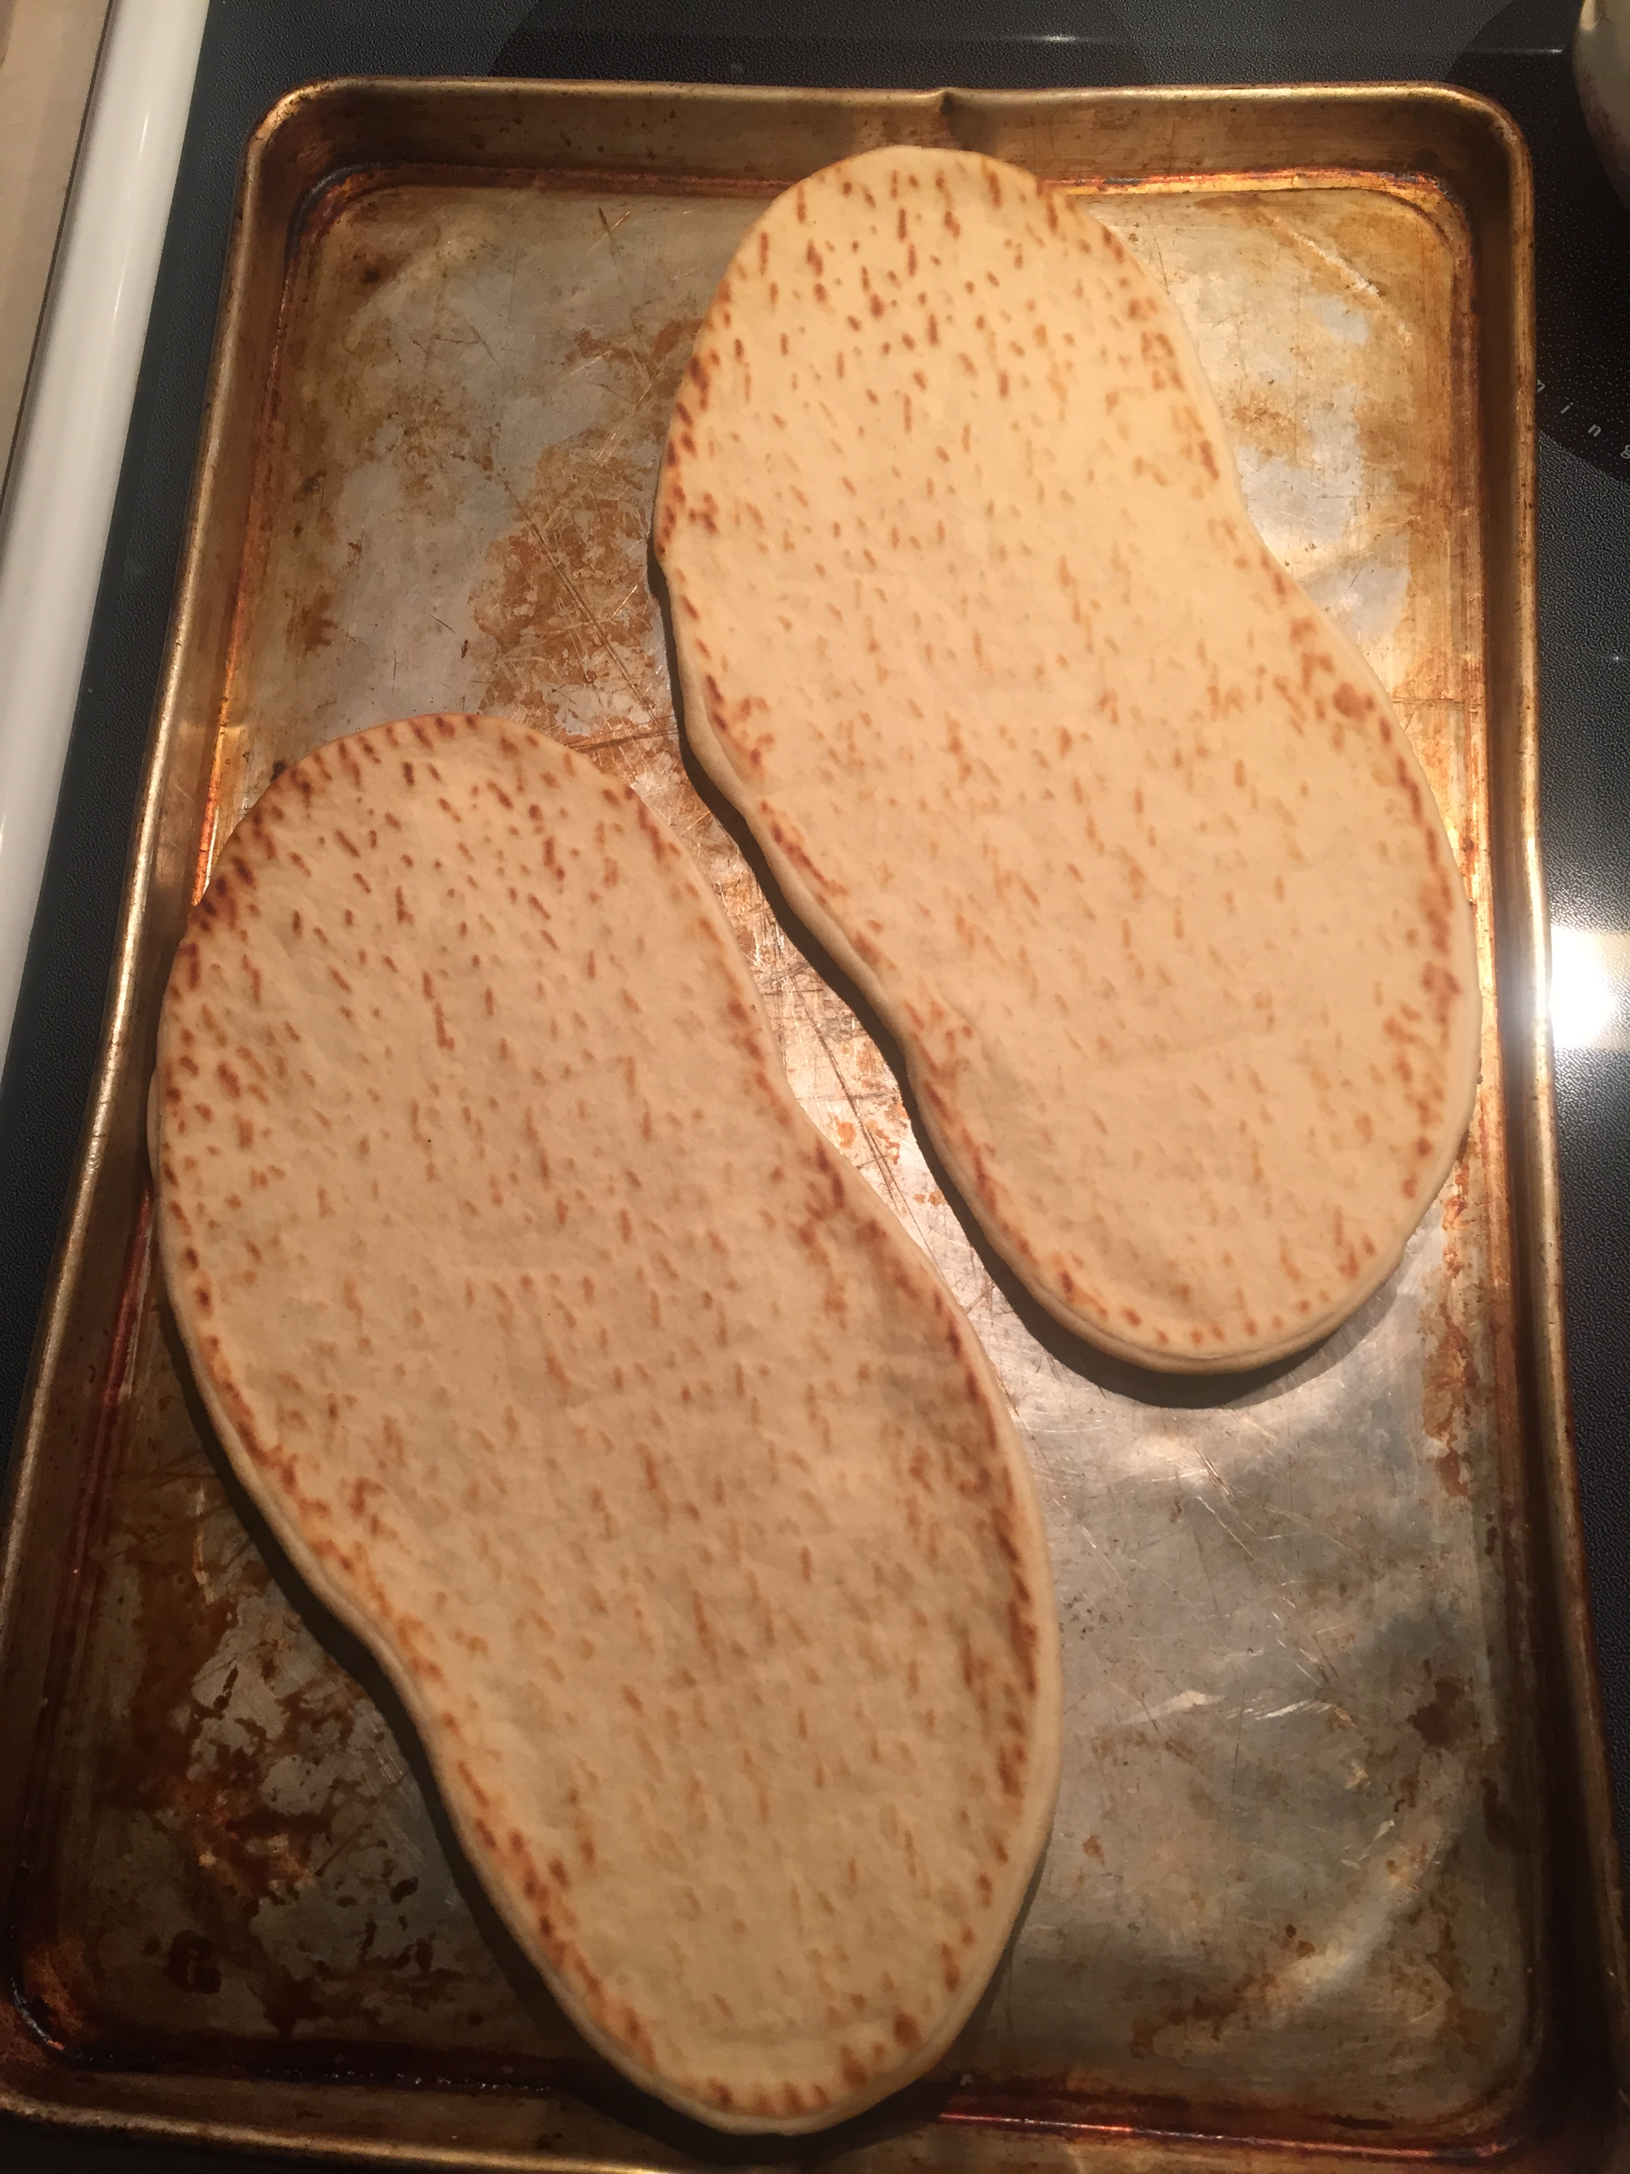

- Put flatbread on baking sheet

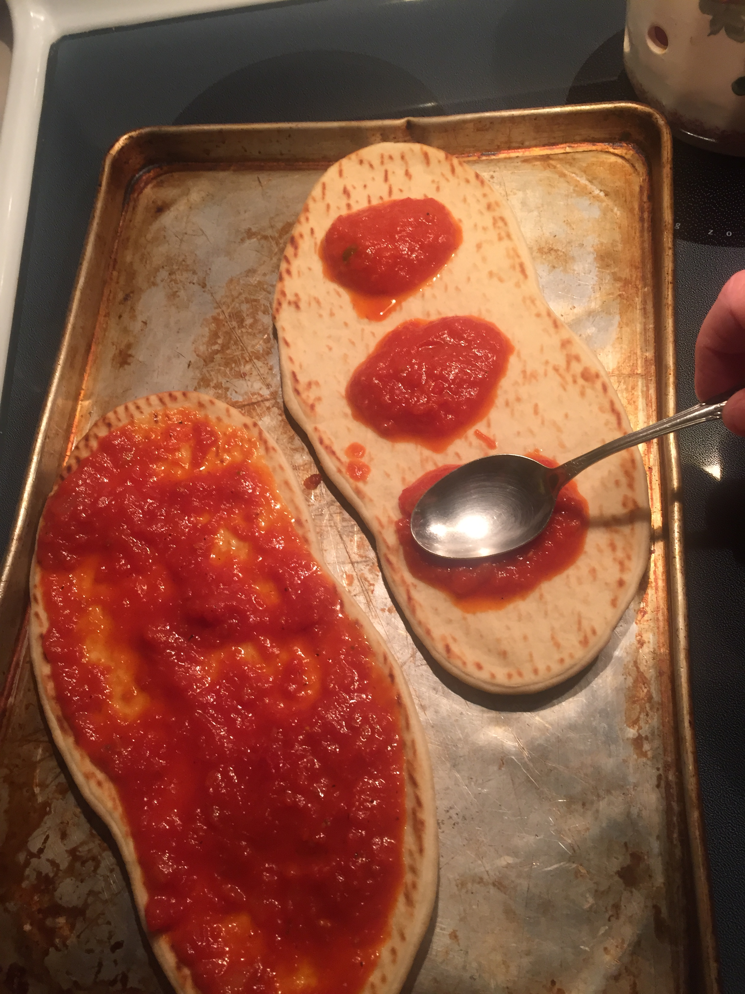

- Spread 3 TBSP sauce on flatbread

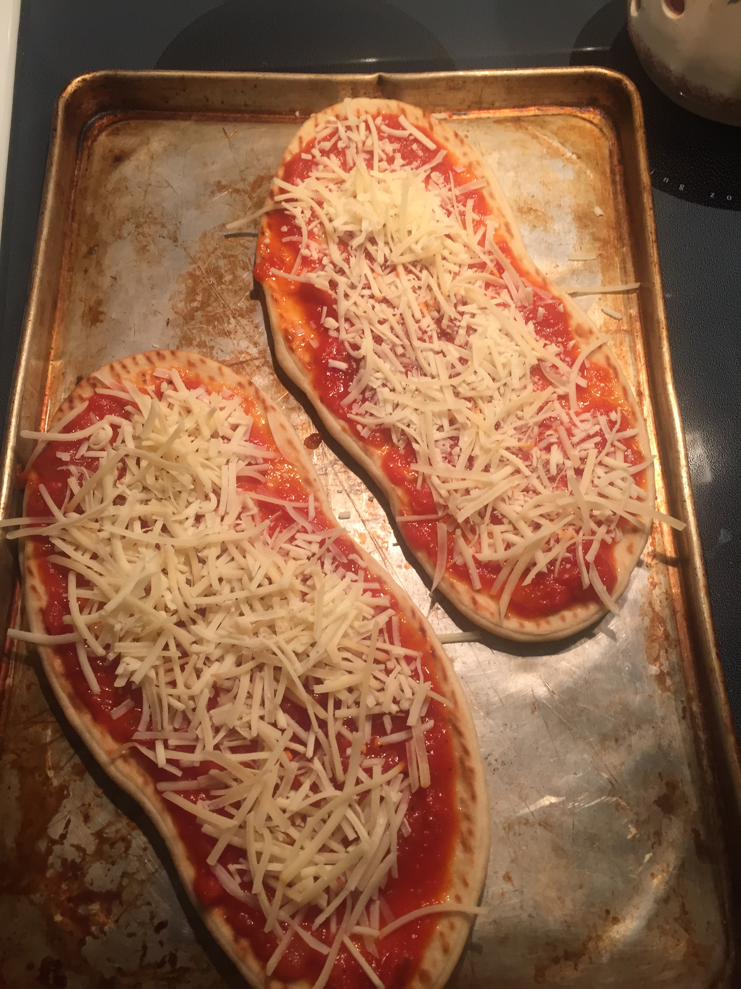

- Sprinkle 1/3 C. Cheese on flatbread



- Add 7 pieces pepperoni if desired.

- Bake in oven for 15 minutes

