DLPC NEWS
---------------------------------------------------------
July 2007 - VOL.7 NO.7
-----------------------------------------------------------------------------------------

In this issue: New releases and discoveries, Additions and Corrections to the web site, and Disney license plate news and information.

-----------------------------------------------------------------------------------------

New Releases
(Cat Num ID Plate)
DL-DD-04 None "SC Sports Center" Quotes lenticular license plate
DW-AK-09 None "Disney’s Animal Kingdom" (Mickey & gang in hot air balloons)
3-D license plate

New Discoveries (Plates released in prior years, but were not listed in the catalog)
AT-DL-03B N/A "2N TOWN" Imagineer Art
CM-FR-26 None "I Am Making The Most of the Disney Difference" frame
CM-FR-27 None "Disneyland Food Operations, I'm Part of the Safest Place On
Earth" frame
CM-FR-28 None "Always Part Of The Magic... Disneyland Resort Alumni Club"
Frame
CM-PI-01 N/A "Pleasure Island 5, Fifth Anniversary 1989-1994" Cast Member
Letter
MI-FR-11 None "Follow Me To... Disney's Vero Beach Resort" frame

-----------------------------------------------------------------------------------------

Additions and Corrections to the Web Site

Revised the following catalog image: DC-CC-01B.
Price tag number 35 that was found on the DL-DD-04 license plate was added to the Price Tag page.
An image of the MI-FR-08 frame, "Pixar Animation Studios" in its package as it was sold was added to the listing.
Mississippi "M1CKEY" and South Carolina "MICKY1" license plates were added to the Disney State License Plates page.

-----------------------------------------------------------------------------------------

Opening & Closing Dates
Opening:

No openings to report.

Closing:

No closings to report.

-----------------------------------------------------------------------------------------

Corrections to the last issue

No corrections to report.

-----------------------------------------------------------------------------------------

News and Information

Catalog Statistics
The catalog has 752 items listed in it. That breaks down to 575 license plates, 110 frames, 41 bicycle plates, 6 property plates and 20 unique items. 375 of the 575 plates were issued from Walt Disney World and there are 173 plastic license plates among the 575-catalogued plates.

e-Bay Auction Activity
Lot of 14 plates $71.99;
Lot of 50 plates $190.40;
CM-RS-03 (Disney's Boardwalk Founders' Day Celebration '97) $20.50;
DR-RS-05 (Disney's Vero Beach Resort)$34.43;
DW-GN-01B (Walt Disney World, Opening, Oct. 1971, Florida) $26.00 (Used) and $35.02;
DW-MG-18 (Stormtrooper) $30.00;
DW-MG-20 (Darth Vader) $29.00;
DW-RS-08 (Disney's Boardwalk) $20.55;
DW-RS-29 (Disney's Grand Floridian Resort & Spa) $33.69 and $63.98;
DW-WP-04 (Disney's River Country) $42.03.

AT-DL-03B "2N TOWN" Imagineer Art
This unique piece was seen on e-Bay in July and was from an Imagineer's collection. The actual artwork can be found on the inside of one of the walls in Roger Rabbit's Cartoon Spin attraction at the Disneyland Resort. The art is made of some sort of plaster and sold for $81.00. See AT-DL-03A.

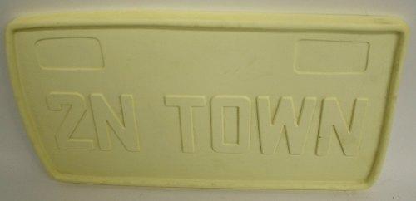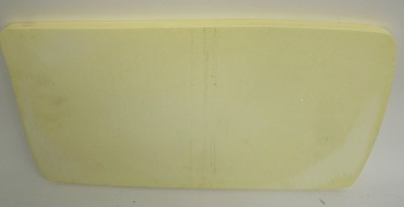

CM-FR-26 "I Am Making The Most Of The Disney Difference" frame
This plastic frame was discovered by Mark Warmann of California in July.
CM-FR-27 "Disneyland Food Operations, I'm Part Of The Safest Place On Earth" frame
This plastic frame was also discovered by Mark Warmann of California in July.
CM-FR-28 "Always Part Of The Magic... Disneyland Resort Alumni Club" frame
This plastic frame was discovered on e-Bay in late July. This is the second alumni frame that has been discovered. The first frame was CM-FR-16, "2000 Disneyland Alumni Club."

CM-PI-01 “Pleasure Island 5, Fifth Anniversary 1989-1994” Cast Member Letter
In mid-July an e-Bay seller posted a CM-PI-01 plate up for auction that also contained the Cast Member letter that was issued with the plate. The letter was signed by Robert Powell, the Human Resources representative for Pleasure Island, and notes that the plate was a special gift given only to PI Cast Members.

DL-DD-04 "SC Sports Center" Quotes license plate [UPC/SKU: 400118 027508]
This plastic lenticular license plate was discovered on e-Bay in late July. The plate was sold at both WDW and Disneyland Resort. The plate was also available at the ESPN Zones across the US. However, only Disneyland Resort and the Chicago ESPN Zone are still selling the plates. They have been discontinued at WDW and the other ESPN Zones.

DW-AK-09 "Disney's Animal Kingdom" license plate [UPC/SKU: 00113 46351]
This plastic 3-D plate was discovered on e-Bay in early July. The plate features Mickey, Minnie, Stitch, Goofy, Pluto and Donald riding in hot air balloons over the Animal Kingdom Park. Icons for the park and major attractions are also featured.

MI-FR-11 "Follow Me To... Disney's Vero Beach Resort" frame
This plastic frame was discovered in July by Mark Warmann of California.

SP-ES-01 and SP-ES-01 ESPN Zone Nevada and New York license plates
A July e-Bay seller notes that these plates were sold on WDW property. The SP-ES-01 (Nevada) was sold at the WDW World of Sports store and the SP-ES-02 (New York) was sold at the Magic Kingdom and in Downtown Disney.

-----------------------------------------------------------------------------------------

Contributions, corrections and comments are welcome and can be sent to:
webmaster@disneylicenseplates.com

