DLPC NEWS
---------------------------------------------------------
November 2018 - VOL.18 NO. 11
-----------------------------------------------------------------------------------------

In this issue: New releases and discoveries, Additions and Corrections to the web site, and Disney license plate news and information.

-----------------------------------------------------------------------------------------

New Releases
(Cat Num ID Plate)
MI-FR-49A None Mickey The True Original (Faces) frame [Plastic]

New Discoveries (Plates released in prior years, but were not listed in the catalog)
(Cat Num ID Plate)
MI-FR-48A None Walt Disney Productions (Mickey) frame
MI-FR-48B None Walt Disney Productions (Mickey) frame

-----------------------------------------------------------------------------------------

Additions and Corrections to the Web Site

EP-FR-07 SKU/UPC number was reported as: 400007 632060 should have been 400007 832060.

Updated images for CM-FR-24 and EP-FR-07.

-----------------------------------------------------------------------------------------

Opening & Closing Dates

Opening:
Marriott International, which operates the Walt Disney World Swan and Dolphin, has revealed the name and new details on the new tower coming to the hotel grounds. The third tower joining the Swan and the Dolphin will be called the Cove. The Cove will include 349 rooms, bringing the total to 2,600 rooms between the three buildings. The Cove will be located across the street from the Swan and Dolphin, near the Fantasia Garden miniature golf course. The Walt Disney World Swan and Dolphin is owned by Tishman real estate firm and Metlife Investment Management and operated by Marriott International.

The Oriental Land Company announced plans for a new Tokyo Disney Resort hotel to be themed to Pixar’s Toy Story franchise. the Toy Story-inspired hotel will bring 600 more guest rooms to the resort. Guests rooms will be themed to Andy’s bedroom and be “designed with colorful furniture and other immersive features inspired by the world of Toy Story.” A new restaurant and shop will also be part of the property. The project is expected to open in 2021.

Last month, Disney announced a new nature-inspired mixed resort along Bay Lake would be coming to Walt Disney World. The name of that resort will be Reflections – A Disney Lakeside Lodge. The new resort is scheduled to open in 2022 on the shoreline of Bay Lake, located between Disney’s Wilderness Lodge and Disney’s Fort Wilderness Resort & Campground.

The new hotel tower at Coronado Springs will be called Gran Destino Tower and will open in July 2019.

Disney Skyliner will makes its debut at Walt Disney World in the fall of 2019. When completed, the Disney Skyliner will connect Disney’s Hollywood Studios and Epcot as well as Disney’s Art of Animation Resort, Disney’s Pop Century Resort and Disney’s Caribbean Beach Resort, and the upcoming Disney’s Riviera Resort.

Closing:
No Closings to report.
-----------------------------------------------------------------------------------------

Corrections to the last issue

EP-FR-07 SKU/UPC number was reported as: 400007 632060 should have been 400007 832060.

-----------------------------------------------------------------------------------------

News and Information

Catalog Statistics
The catalog has 1,137 items listed in it. That breaks down to 779 license plates, 238 frames, 54 bicycle plates, 10 property plates and 56 unique items. 468 of the 779 plates were issued from Walt Disney World and there are 217 plastic license plates among the 779-catalogued plates.

e-Bay Auction Activity
CM-FR-19 (Disneyland Resort Cast Member, “Hi Ho, Hi Ho, It’s Off To Work We Go…”) $25.00;
CM-FR-24 (Thanks To You The Magic Works) $23.99;
CM-FR-46 (We Make the Magic Happen! The Walt Disney Company) $29.00;
CM-FR-51 (Cast Member Disneyland Resort) $29.00;
CM-PI-02 (Pleasure Island Walt Disney World) $24.85;
DL-FR-20 (Disneyland 50 Happiest Homecoming On Earth) $40.00;
DL-FR-23 (Disneyland Resort) $21.95, $23.50, $24.00 (twice), $24.99, $26.95, $33.99, $38.99 and $39.95 (three times);
DL-FR-42 (2018 Disneyland Resort) $22.99;
DS-FR-10 (Walt Disney Studios Mickey Mouse) $28.46, $29.00 and $29.96 (twice);
DW-EC-02 (Walt Disney World, Epcot Center, The Newest Wonder of the World) $23.98;
DW-EP-09 (Epcot) $59.00;
DW-EP-25 (Test Track Presented by Chevrolet) $24.99 (twice);
DW-GN-01B (Walt Disney World, Opening, Oct 1971, Florida) $20.50;
DW-GN-02A (Walt Disney World) $29.95;
DW-GN-08 (Walt Disney World) $38.92;
DW-MK-19 (The Haunted Mansion Doom Bugy Magic Kingdom, RIP, 999 Ghosts) $35.00;
DW-MK-20 (The Haunted Mansion Doom Bugy Magic Kingdom, RIP, 999 Ghosts) $56.00 and $64.50;
ED-GN-03 (Euro Disney, Main St. Motors) $46.54;
ED-GN-07A (Euro Disney Goofy Express) $20.00;
MI-FR-24 (Jack Skellington) $30.00;
MI-FR-48A (Walt Disney Productions) $25,00;
MI-FR-48B (Walt Disney Productions) $25.00;
MI-OT-01B (Bicentennial, America on Parade, 1776 - 1976) $30.00;
MI-OT-13 (Mickey and Gang) $22.99;
MI-OT-113 (Special... Marie Sweet) $27.77;
MI-OT-128 (Marie) $27.78.

MI-FR-49A "Mickey The True Original (Faces)" frame
This flat plastic frame was discovered on e-Bay in early November. The frame is the same as MI-FR-49, but with a background insert celebrating Mickey's 90th birthday. The frame was produced by Chroma Graphics of Maryville, Tennessee and it was made in China. It is currently available on e-Bay. This is likely to be the only 90th birthday celebration item.

MI-FR-48A "Walt Disney Productions" (Mickey) frame
MI-FR-48B "Walt Disney Productions" (Mickey) frame
These two frames were discovered on e-Bay also in early November. The frames are circa 1929-1986, the period of which the Disney Company was known as Walt Disney Productions. The frames are similar to the MI-FR-48 frame that was personalized by Walt Disney animator/artist Jay J. Gould. Gould worked at the Disney Studios from 1936-1979. Gould's tenure at Disney would further narrow the circa time frame to 1936-1979. The difference between the two frames is the location of the "Walt Disney Productions" banner. One appears on the top banner and the other appears on the bottom banner. Little is known about these frames, however they appear to be a Cast Member exclusive.

A word about the "e-Bay Auction Activity" sales prices
Several questions have been asked about the e-Bay sales prices shown in the DLPC News. I hope this will clear up any confusion that has arisen due to the data shown. First of all, I set a minimum price of $20.00 to be listed in the DLPC News. It would take to much time and space to list all of the e-Bay sales. I determined the $20.00 break point based on my collection. The average cost of a plate in my collection was $20.00. This would mean that anything $20.00 and over would be noteworthy and listed in the DLPC News.

e-Bay has made it more difficult to obtain sales price data over the past few years. They no longer show "Buy-It-Now" sales prices due to complaints by sellers who want to keep "accepted offers" private. This keeps buyers from pointing out to the seller that a previous item sold for a certain amount below the current asking price. Due to this, these sold items are not listed since I don't have a value to list.

Another issue comes from auction listings containing multiple items. Under a multiple item auction it is difficult to assign the total value to a certain plate. To make this easier, the total sale price is divided by the number of items in the auction to determine the per piece sales price. Many times the total sales price does not divide equally among the plates. An example was a recent sale of MI-OT-113 & MI-OT-120 for $55.55 in a single auction. The individual sales price would be $27.775. To make listing easier, one plate is listed as $27.77 and the other as $27.78. This is the cause of not being able to find an auction listing for some of the shown prices.

I recently discovered that the sales prices shown in the "search results list" is different than the "sold price" on the auction listing. An example is e-Bay item # 264046375867 that sold on November 17th. The "search results list" showed an ending price of $35.00 and the auction listing shows the final sales price as $20.00. The item is listed as being in the U.S., so there would not be any currency conversion and there was only one bid. I have come across this numerous times before. I have sent e-Bay several e-mails and spoke to the "help line" in person and have not received any answer to my question about the different prices. I use the sales prices shown in the "search results list" to compile the sales price data used in the DLPC News.

e-Bay Item # 264046375867

e-Bay "Search Results List":

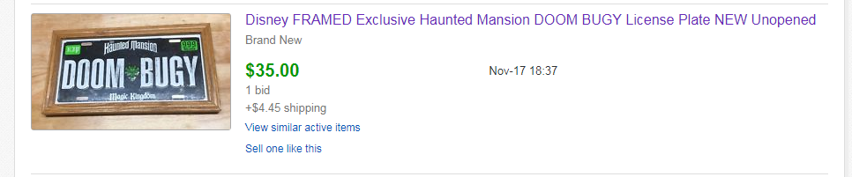

e-Bay Auction Listing:

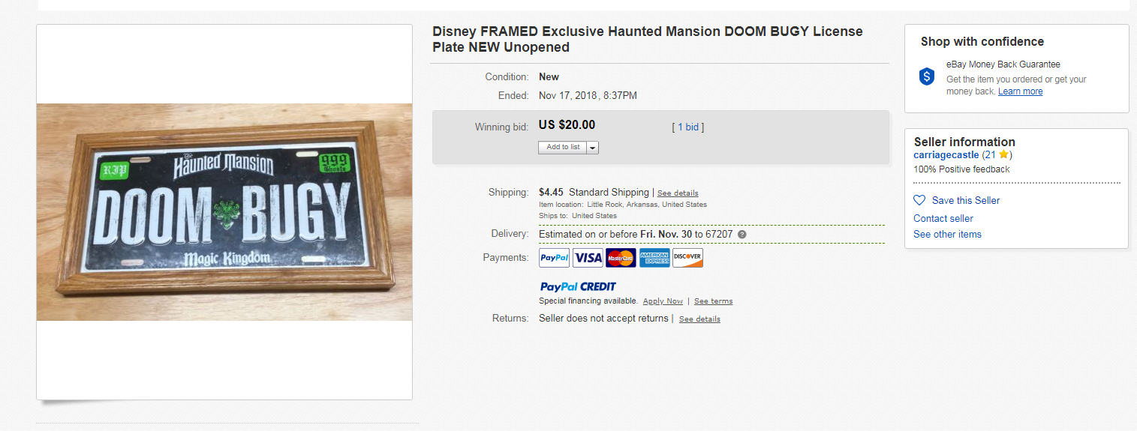

The primary reason for showing these sales prices is to show current values and sales activity. This helps me when I find a plate on my want list to know if the seller is providing a good deal or a totally unrealistic asking price.

------------------------------------------------------------------------------------------
Contributions, corrections and comments are welcome and can be sent to:
webmaster@disneylicenseplates.com

