DLPC NEWS
---------------------------------------------------------
September 2021 - VOL. 21 NO. 9
-----------------------------------------------------------------------------------------

In this issue: New releases and discoveries, Additions and Corrections to the web site, and Disney license plate news and information.

-----------------------------------------------------------------------------------------

New Releases
(Cat Num ID Plate)
No new releases.

New Discoveries (Plates released in prior years, but were not listed in the catalog)
(Cat Num ID Plate)
DW-RS-55A None Official Travel Trailer Fort Wilderness Walt Disney World A Product of Fleetwood Enterprises (two bolt holes, Made in USA marking) [Plastic]
DW-WS-15 Unknown Norway - World Showcase Flag

-----------------------------------------------------------------------------------------

Additions and Corrections to the Web Site
The DW-WS-06 (Mexico World Showcase Flag) plate has been discovered to have been sold at Walt Disney World with both the large and small Mexican Coat of Arms in the center of the flag.

Small Coat of Arms Larger Coat of Arms
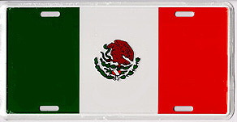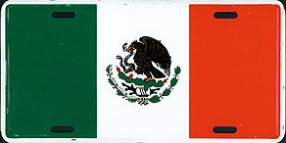

Until recently only the small Coat of Arms license plate had been found to be sold at World Showcase in Epcot at Walt Disney World. A recent discovery of the larger Coat of Arms license plate was found with $3.00 Walt Disney World price tag. The small Coat of Arms license plate was first discovered with a $5.00 Disney price tag. Since Disney does not produce these flag plates, it now seems possible that there might be other variations among the flag plates that were already found to have been sold at Walt Disney World.

-----------------------------------------------------------------------------------------

Opening & Closing Dates

Opening:
Walt Disney World's 50th Anniversary starts October 1, 2021.

Disney Vacation Club Members will soon have more options available at the Villas at Disney’s Grand Floridian Resort & Spa thanks to an expansion and enhancement to existing villas that will debut in the Summer of 2022. The expansion will add approximately 200 proposed resort studios, a Disney Vacation Club room type unique to The Villas at Disney’s Grand Floridian Resort & Spa. Existing villas including deluxe studios, one- and two-bedroom villas, and three-bedroom grand villas will be enhanced.

Walt Disney World announced today that Guardians of the Galaxy: Cosmic Rewind will open in 2022. The new attraction will be using the space previously occupied by Universe of Energy, which will now be known as the “Wonders of Xandar” pavilion. The attraction is intended to be a family-friendly adventure on a new type of roller coaster that features 360-degree vehicle rotation and includes Disney’s first reverse launch system on a coaster.

Star Wars: Galactic Starcruiser will open March 1, 2022
Unlike anything that exists today, the new luxury resort Star Wars: Galactic Starcruiser, will completely immerse guests in an authentic Star Wars story. The journey through space begins the moment guests arrive, as everyone boards a launch pod and ascends to the Halcyon. Once aboard the Starcruiser, guests will embark on two-night, two-day experience that's out of this world. From exotic eats and character encounters to walking the ship's bridge and learning the finer arts of lightsaber wielding, the galactic journey is perfect for fans of any age. The adventure will be “alive with characters and stories that unfold all around them during their voyage through the galaxy, and every window has a view of space!” This two-night, two-day Star Wars experience will bring a massive galaxy of iconic characters to life.

Closing:
No additions or corrections.

-----------------------------------------------------------------------------------------

Corrections to the last issue

No corrections to report.

-----------------------------------------------------------------------------------------

News and Information
Catalog Statistics
The catalog has 1,202 items listed in it. That breaks down to 797 license plates, 249 frames, 84 bicycle plates, 10 property plates and 62 unique items. 477 of the 797 plates were issued from Walt Disney World and there are 218 plastic license plates among the 797-catalogued plates.

e-Bay Auction Activity
CA-FR-01 (Coming In 2001! Disney's California Adventure) $40.00;
CM-DC-01 (Disney Cruise Line Inaugural 1998) $24.99;
CM-DW-02 (Walt Disney World 20th Anniversary 1971 1991) $49.99;
CM-DW-05 (Opening Day Oct 1971 Company D) $75.00;
CM-FR-04A (We Make The Magic! Walt Disney Imagineering) $27.00;
CM-FR-04B (We Make The Magic! Walt Disney Imagineering) $71.55;
CM-FR-04C (We Make The Magic! Walt Disney Imagineering) $47.99;
CM-FR-29 (I Make The Magic Happen Disneyland Resort Cast Member) $20.00;
CM-FR-34 (Part of the Magic The Walt Disney Company) $26.99;
DC-GN-02A2 (Disney Cruise Line, Discover Uncharted Magic, Inaugural 1998) $20.00;
DL-FR-04 (It's A Sign of Good Character Disneyland) $22.00;
DL-FR-05 (1972 1996 Main Street Electrical Parade Disneyland) $22.00 and $25.00;
DL-FR-09 (Annual Passholder Disneyland) $25.00;
DL-FR-19 (Disneyland The Happiest Place On Earth) $22.00;
DL-FR-23 (Disneyland Resort) $29.99;
DL-FR-43 (Disneyland Resort Where Magic Lives) $29.99, $30.00 and $49.99;
DL-FR-44 (2021 Disneyland Resort) $29.99;
DL-GN-01 (55 - 85, Disneyland, The best has just begun) $21.95;
DL-GN-03 (Disneyland 1987) $21.95;
DL-GN-08B (Disneyland the Original 91) $20.00;
DL-GN-10A (Disneyland, The Original) $22.50;
DR-RS-02 (Disney's Vero Beach Resort) $24.99;
DS-GN-01 (The Walt Disney Studios) $22.50;
DW-AK-01B (Disney's Animal Kingdom, A New Species of Theme Park, Opens 1998) $20.00;
DW-AK-02A (Disney's Animal Kingdom) $23.97;
DW-EC-01A (Walt Disney World, Epcot Center, The 21st Century Begins October 1, 1982)
$39.99 (twice);
DW-EC-01B (Walt Disney World, Epcot Center, The 21st Century Begins October 1, 1982)
$20.00;
DW-EC-02 (Walt Disney World, Epcot Center, The Newest Wonder of the World) $20.50, $24.95 and $26.00;
DW-FR-01A1 (Walt Disney World Been There, Done That, Going Back!) $27.75;
DW-FR-12 (Walt Disney World Where Dreams Come True) $29.99 and $33.95;
DW-FR-13 (2021 Walt Disney World) $21.95 and $22.90;
DW-GN-01B (Walt Disney World, Opening, Oct 1971, Florida) $79.31, $163.50 and $185.99;
DW-GN-02A (Walt Disney World) $20.22, $20.47, $25.00 and $27.64;
DW-GN-08 (Walt Disney World) $20.23;
DW-GN-13 (Walt Disney World) $30.00;
DW-GN-42 (Walt Disney World) $24.99;
DW-PI-01 (Pleasure Island) $29.99;
DW-RS-01 (Fort Wilderness Resort) $129.00;
DW-RS-02A (Disney Vacation Club) $50.50;
DW-RS-03A (Disney's Wilderness Lodge) $79.99;
DW-RS-18 (Disney's Dixie Landings Resort) $45.00;
DW-RS-21 (Disney's Beach Club Resort) $35.00;
DW-RS-27 (Disney's Boardwalk Villas) $35.00;
DW-RS-29 (Disney's Grand Floridian Resort & Spa) $29.99;
DW-RS-30 (Disney's All Star Movies Resort) $25.00;
DW-RS-51A (Disney's Fort Wilderness Resort & Campground) $99.99;
DW-RS-55A (Official Travel Trailer Fort Wilderness Walt Disney World A Product of Fleetwood Enterprises) $29.95;
DW-WP-01 (Typhoon Lagoon, Walt Disney World) $29.99;
ED-GN-04 (Euro Disney) $29.99;
MI-FR-08 (Pixar Animation Studios) $55.00;
MI-FR-51 (Disney Vacation Club Member) $32.95 and $34.99;
MI-OT-15 (Tigger) $24.89;
MI-OT-83 (runDisney 13.1) $39.50.

News:

DW-RS-55A "Official Travel Trailer Fort Wilderness Walt Disney World A Product of Fleetwood Enterprises
This flat plastic plate was discovered on e-Bay in late September. It is a variation of the DW-RS-55 plate. The DW-RS-55 plate has four bolt holes. The DW-RS-55A only has two bolt holes. The DW-RS-55A plate also has a "Made in USA" marking in the lower right corner of the plate. The DW-RS-55 plate does not have that marking. Not much is known about these plates. The DW-RS-55 plate was discovered back in October of 2006. Since then only three of these plates have made it to auction on e-Bay.

DW-WS-15 "Norway - World Showcase Flag"
This aluminum license plate was also discovered on e-Bay in late September. It has taken around 33 years for this plate to surface. The Norway Pavilion was opened on May 6, 1988 in Epcot's World Showcase at Walt Disney World. It was the eleventh pavilion added to World Showcase. None of the World Showcase flag plates were manufactured by Disney and it appears that several versions of the flag plates were sold at Walt Disney World. This plate was confirmed as being sold at Disney due to the Disney price tag attached. The plate has a five-digit ID number on it, however it can not be read due to the quality of the e-Bay images. The e-Bay seller found the six flag plates (Mexico, Norway, Italy, US, France and Germany) still in shrink wrap and with the Disney price tags attached at a thrift store in Wyoming.

Disney License Plate Items Celebrating WDW's 50th Anniversary
Disney has released two items, a DW-GN-02A license plate pin and a DW-GN-01B license plate sold in a anniversary box.

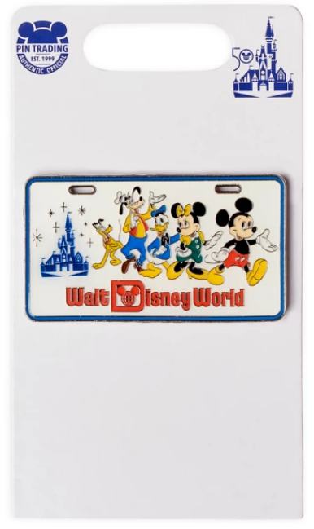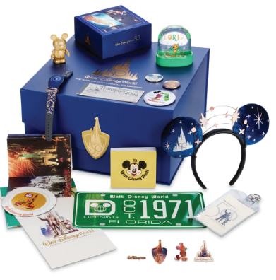

DW-GN02A Pin DW-GN-01B License Plate

You can find both items on the DisneyStore.Com website (https://www.shopdisney.com/) by searching for "license plate" (without the quotes). The pin sells for $12.99 and the DW-GN-01B license plate is a pre-order item with a hefty price of $500.00. The anniversary box set has seventeen Disney items and is limited to a total of 2,000 boxes which, will be available after January 1, 2022.

Unfortunately, the Disney Store listing for the anniversary box doesn't reveal a lot of information on the license plate. This may be a reproduction or may be an original plate from the original manufacturer made back in 1970. I have sent a message to the Disney Store, but (as usual) I have not received any reply.

Thank you to Mark Warmann of California for reporting the discovery of the anniversary box.

You can find the pin on e-Bay but so far all the sellers have way over-priced the pin, doubling or tippling the original Disney purchase price.

------------------------------------------------------------------------------------------
Contributions, corrections and comments are welcome and can be sent to:
webmaster@disneylicenseplates.com

