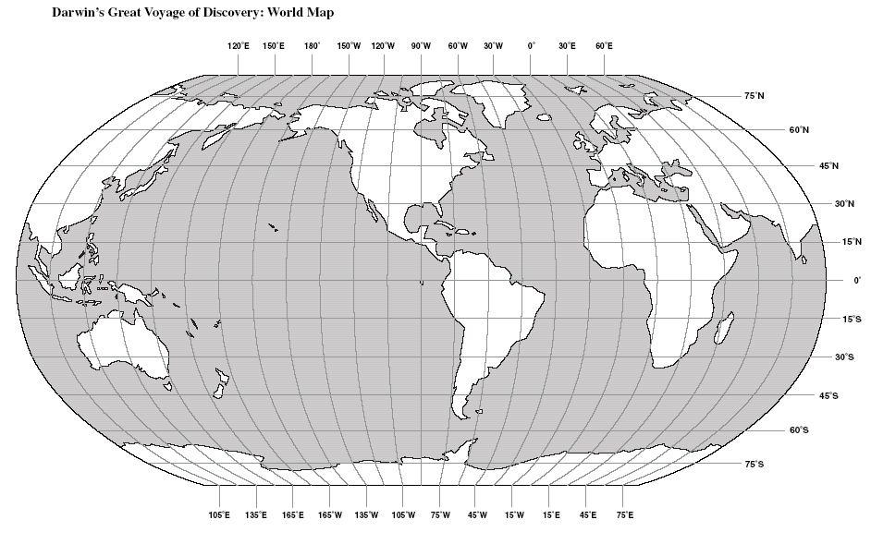
use a 4-pointed star to plot your points
then join them using a line tool!
have fun and delete all this before you start..... Mr. Edwards
Hello CCC Year 10!
If you want to add text, use a text box
You can also copy pics from the web and paste them on this map!

