Where Was This Ship on 20 February, 1962?
Dr Ross J. Smith, PO Box 550, South Hurstville, NSW 2221, Australia
SU5002, rossjsmith@optusnet.com.au
Revised May 2023

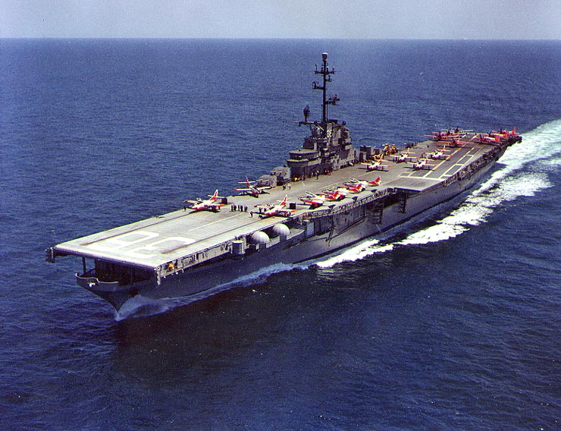

When asked this question most Recovery Ship collectors will answer that the USS Antietam was part of the MA-6 Recovery Force. When pressed, some knowledgeable collectors will answer that she was in the Pacific, probably as part of TF-130 (the Navy’s Pacific Recovery Fleet), in case there was a major problem with John Glenn’s Mercury capsule and it was forced down in the wrong ocean. This was the situation I found when I was researching an update on my articles on Mercury covers.
However a number of inconsistencies developed. The first red flag occurred when I read some information I had purchased on eBay which included a history of TF-130. The document stated that ‘TF-130 first deployed [on] October 3, 1962, when the aircraft carrier USS Kearsarge recovered astronaut Walter Schirra in Mercury 8’. Clearly TF-130 was not involved with MA-6. However, this didn’t eliminate the possibility that the Antietam was stationed in the Pacific on an ad hoc basis. Next I discovered that at that time, the Antietam’s home port was Penascola on the East Coast. It would therefore make far more sense (at least to me) to use one of the Pacific based carriers such as the USS Ranger or the USS Enterprise if a carrier was required in the Pacific. If didn’t make sense to sent an Atlantic carrier to the Pacific when there were several much closer carriers. Thirdly, why would a single carrier be used. It was my impression that carriers were always accompanied by at least a couple of other ships such as a destroyer and an auxiliary vessel. This was later confirmed by Steve Durst. Yet no mention is made of any other Recovery ships in the Pacific. Finally I found a reference to the Atlantic Recovery Force being made up of 24 ships including 3 carriers which were stationed in the 8 planned landing areas in the Atlantic (not including tracking ships). Looking at my list of ships believed to be involved in the Atlantic I had 23 ships including 2 carriers. Add the Antietam and you get the magic number of 24 ships including 3 carriers! I was convinced.
Then I received a book I had ordered a couple of weeks earlier. This is the only book written specifically about the Navy’s role in the US Space program. To my shock, it listed the Antietam as being located in the Pacific for MA-6! What to do? I decided to do one final search for a document written at the time which documents the recovery effort. Finally, after an exhaustive search, I found the ‘smoking gun’, a NASA document written immediately after the mission. Despite not including the figures mention in the text, it had a full description of the recovery effort. There were 24 ships in 8 areas in the Atlantic, contingency Recovery Aircraft located in both the Pacific and the Atlantic plus tracking ships. No mention of any ships in the Pacific. Given the detail and the timing of the report, I consider it conclusive.
The answer to my original question is that the USS Antietam was part of the Atlantic Recovery Force for John Glenn’s Mercury 6 flight.
A cover from the USS Antietam for MA-6, seen below, is quite difficult to obtain.

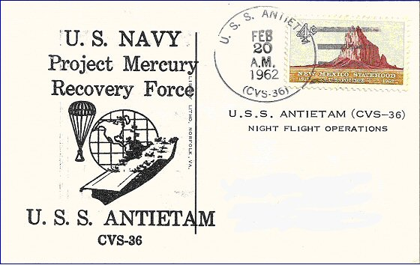

Addition May 2023
The following photo (thanks to Kevin Rossiter) confirms that the USS Antietam was in the Atlantic Ocean during MA_6.

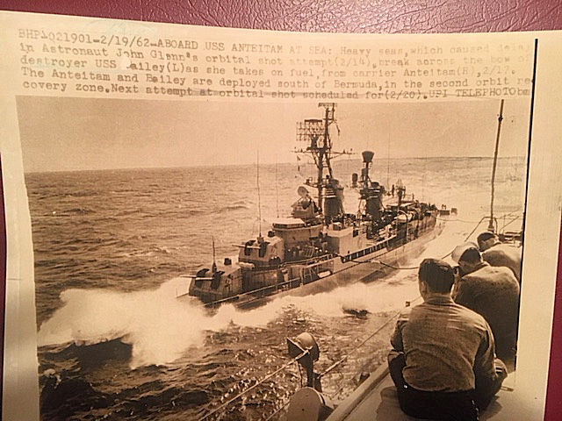

Now for MA-7
This now lead to me questioning the list of Recovery ships for MA-7, Scott Carpenter’s flight on May 24, 1962. This time, a number of sources including Don Blair’s book list three ships in the Pacific; the USS Hunt, USS Remey and the USS Wren. But were these ships really in the Pacific? Again, they weren’t part of TF-130 as mentioned above. However, they could still have been in the Pacific as an ad hoc Recovery Force.

My first clue came with a study of a cover from the USS Hunt (see below). It is clearly marked ‘Aurora –7 Station –3 37° 12’W. 31° 57’M which is the middle of the Atlantic. In addition, Station 3 (or C as it is generally called) was in the Atlantic, not the Pacific. This was a strong indication that the USS Hunt was not in the Pacific for MA-7. Still I needed more proof and what about the other ships?. Again I searched the Web for a document written at the time. And again I found a copy of the NASA technical report for MA-7, written on 15 June 1962. This document contains the most detailed report on recovery operations that I have ever seen. From it I could even tell how many contingency recovery aircraft were on alert in Australia (or any where else) for the mission (two from Townsville on the East coast and two from Perth on the West coast)! It has detailed charts of both the Atlantic and the Pacific. Low and behold, there is no mention of any ships in the Pacific, just aircraft from a number of different locations. Considering when this report was written and the detail involved, I again consider this conclusive unless someone can produce ships' logs that say differently.
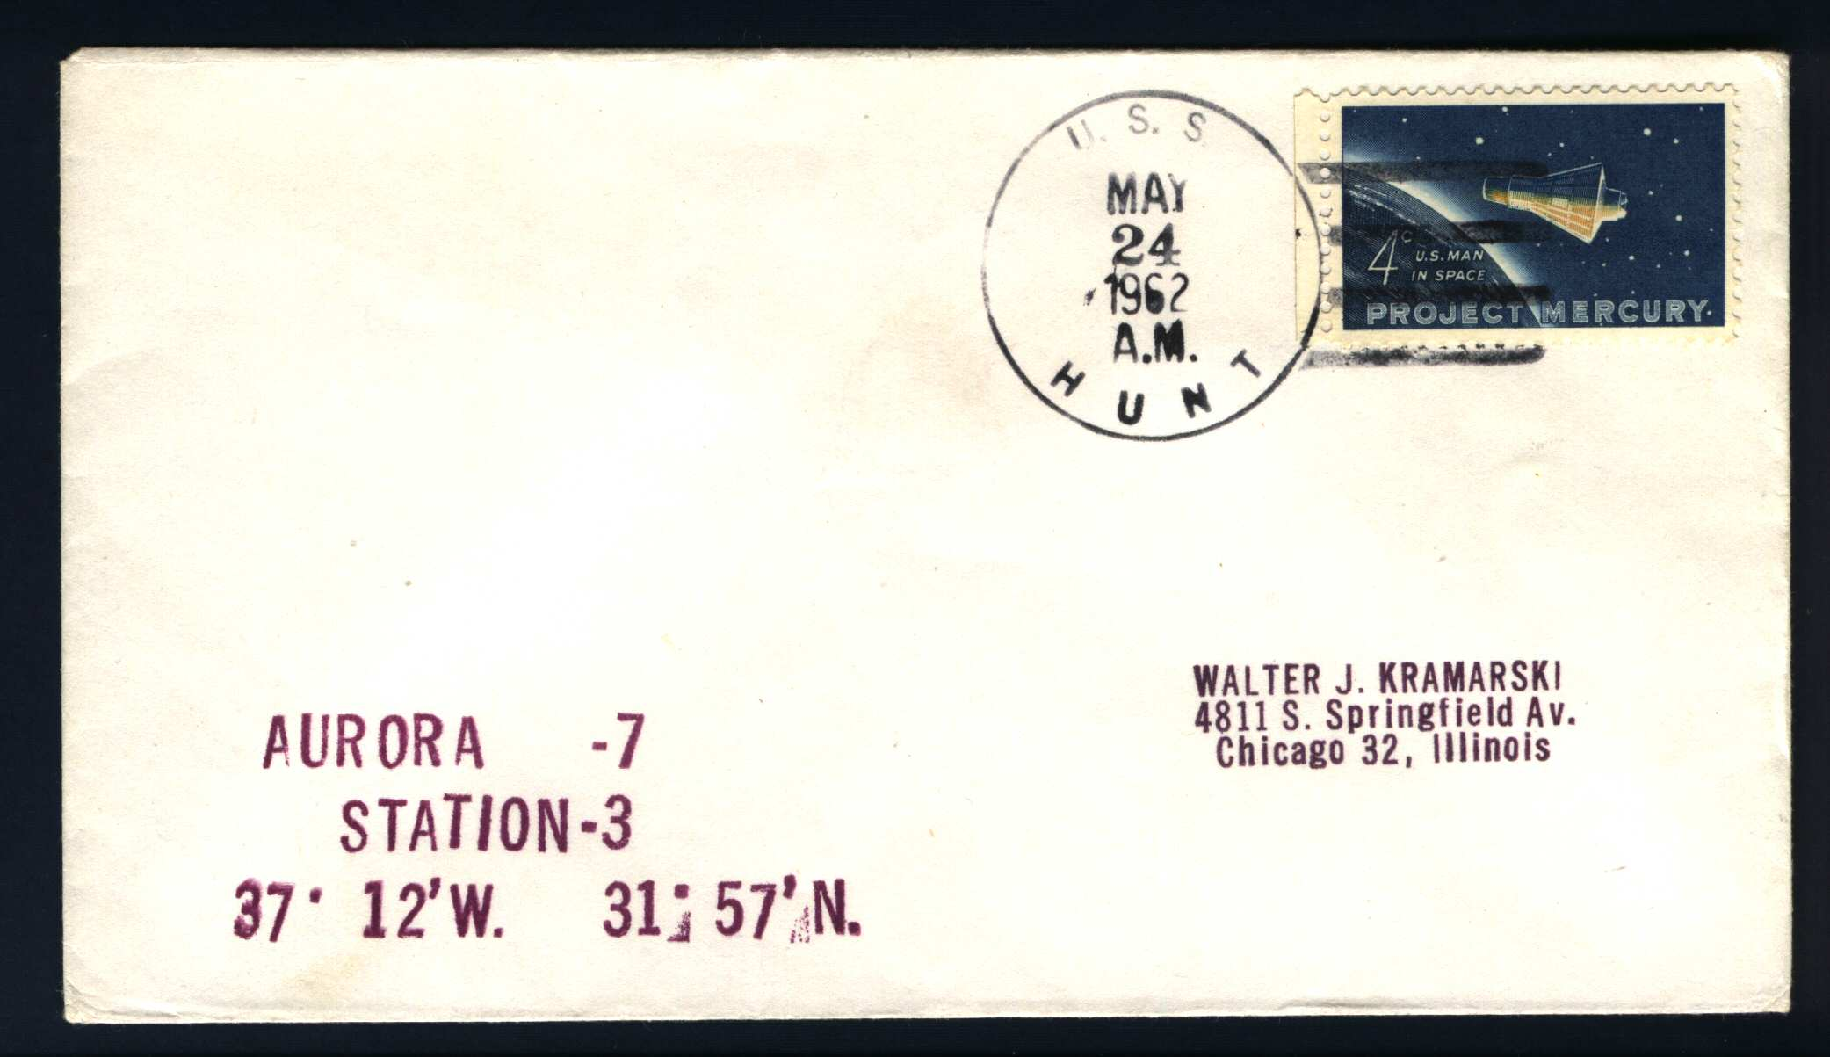
It is therefore clear that the first use of a Pacific Recovery Force occurred during Walter Schirra’s Mercury 8 flight!

When Did These Errors First Appear
The earliest full list of ships involved in the various Mercury missions that I’ve seen dates from June 30, 1975. It is Letter Serial 58 from the Commander Manned Spacecraft Recovery Force, Atlantic, Task Force 140, Norfolk, VA, for U. S. Navy ships which have participated in spacecraft recovery duties and is signed by Chief of Staff, Patrick S. Dowling, CAPT, USN. It in the USS Antietam is listed as being in the Pacific for MA-6 and the USS Hunt, USS Remey and the USS Wren in the Pacific for MA-7. It is amazing that the US Navy can’t even put together a correct list of ships involved in the various Manned Space missions. Later lists from NASA have perpetuated the error which has then been carried though to the book by Don Blair.

Another Myth – Alan Shepard’s Weather Ship
I have a cover dated 5 May 1961 from the USCGC Eastwind (see below). This cover, which is relatively common, is usually described as coming from a Weather Ship for Alan Shepard. This initially seems perfectly reasonable as the Eastwind was involved in metrological readings (amongst others) and the date is correct. However, this turns out to be an urban myth! In a upcoming article Steve Durst writes ‘Space Unit member Dennis Dillman in a close review of the Cutter’s deck logs at the National Archives in Washington, DC, July 17, 2006, clarifies this information. His review of the USCGC Eastwind’s deck logs determines that on the date of Alan Shepard’s recovery, Eastwind is docked at the King Constantine Pier in Piraeus, Greece. The ship is not involved in recovery operations or duties as a “weather ship” or other recovery duties for Shepard’s flight as previously thought. It is coincidental that covers postmarked by the ship in port in Greece have the same date for the launch and recovery of Astronaut Alan Shepard near Grand Bahama Island in the Atlantic Ocean operating area.’ It seems that the Eastwind had recently completed a mission in the Mediterranean measuring sea temperatures etc and this cover may have been a commemorative cover for the end of that mission.

This case shows that, in the end, the only absolutely reliable method of determining whether a ship was involved or not is to check the ship’s log.

A New Class of Recovery Ship
My research also confirmed a fact that I had only been vaguely aware of previously. For some missions (maybe even all the missions) there were a number of ships on standby in or near various ports. These ships, while not Secondary Recovery Ships, were an important part of the mission. They were stationed in areas which were outside the likely splashdown zone and were on active duty at the time of recovery. If notified, they could immediately set sail for the new splashdown zone. Together with the contingency Recovery aircraft they would be able to recovery both the astronaut(s) and the capsule. I prefer to call these ships, Contingency Recovery Ships (CRS) rather than Standby Recovery Ships (the abbreviation would be rather confusing). Unfortunately, not only are the names of such ships undocumented, but their locations are also unknown. It is possible, maybe even likely, that there were a number of such ships stationed in the Pacific for MA-6 and MA-7. Unless someone wishes to search the individual ships’ logs (I would start with the Pacific based aircraft carriers), we may never know their names.

This leads to an observation. Many ships that were not Secondary Recover Ships issued covers for various missions, especially the Mercury missions. While most of these are certainly commemorative only, maybe some are from Contingency Recovery Ships. Now, wouldn’t that be a discovery! It would be a nice talking point for someone’s exhibit.

Document entitled Manned Spacecraft Recovery
The USS Ranger was definitely in the Pacific at the time and the USS Enterprise may have been
I found that coincidently Steve Durst was researching exactly the same area and since then we have exchanged much information
‘Splashdown : NASA and the Navy’, Don Blair, Turner Publishing Company (2004)
‘Postlaunch Memorandum Report for Mercury-Atlas No. 6 (MA-6), Part 1, NASA Manned Spacecraft Center, March 5, 1962
Postlaunch Memorandum Report for Mercury-Atlas No. 7 (MA-7), Part 1, NASA Manned Spacecraft Center , June 15, 1962
Thanks to Steve Durst for pointing out this letter
It should also be noted that this document contains numerous other errors including miss-spellings, incorrect ship designations and missing ships. All, in all, a very poor reflection on either the author or Navy records.

